The Era: (Takes place in Vienna)
Research the specific era that this play takes place in
Notable events from 1890-1900
- 1892 European Figure skating competition is hosted by Vienna
- Palais Rothschild is built 1894, as well as the 1894 European figure skating championships
- 1895 Palais Lanckoronski built
- 1898 Cycling world championship
What do buildings look like?
Brick and Masonry with detailed windows and carved stone detailing.
Were roads cobble or dirt or paved?
Cobble and paved
Was there electricity?
No
How did people get around?
Horse and buggy
What seasons does this play go through?
Winter and Spring
The Characters:
Girl of the street
Personality Traits?
Cheeky, Smooth, a little reckless
What’s their job?
Prostitute
Social class?
Lower class
Soldier
Personality Traits?
Reckless, Strong-willed, adventurous
What’s their job?
Social class?
Middle class/ working class
Maid
Personality Traits?
Timid, shy, giggly, swayed easily
What’s their job?
Social class?
Lower class/ working class
Young gentlemen
Personality Traits?
Shy, unsure of what he wants, a little awkward
What’s their job?
Unknown
Social class?
Middle-upper class
Wife
Personality Traits?
Put together, a little strict, but also a little reckless, and sometimes a little weak
What’s their job?
Unknown
Social class?
Middle class
Husband
Personality Traits?
Romantic, questioning, seems innocent but isn’t
What’s their job?
Unknown
Social class?
Middle class
Young miss
Personality Traits?
Caring, Responsible
What’s their job?
Stays at home to care for family full time
Lower class
Poet
Personality Traits?
A little deceiving, playful, fun.
What’s their job?
Poet
Social class?
Middle class
Actress
Personality Traits?
Playful, Naïve but also strong
What’s their job?
Actress
Social class?
Middle-upper class
Count
Personality Traits?
Put together, but also extremely frazzled, older
What’s their job?
Unknown
Social class?
Upper class
What clothes were mentioned in the script?
Cloaks, Shawls, Nightgowns, and Veils
Where does each scene take place? Find visuals for each scene.

Scene 1
Heid, Hermann. “Collection.” Rijksmuseum.Nl, www.rijksmuseum.nl/en/collection?collectionSearchContext=Art&page=1&sortingType=Popularity&facets%5B0%5D.id=8dd4112b89d044f5ae518336be04f31a&facets%5B0%5D.nodeRelationType=HasRijksTheme. Accessed 19 Oct. 2025.
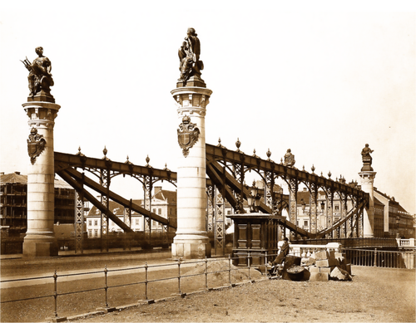

Scene 2
Shields, William Gordon, 1883 - 1947. Man and Woman Walking along Fenced Path. matte finish warm-toned gelatin silver print, c. 1910s. Smith College Museum of Art, Northampton, MA; Gift of Nicole Moretti Ungar, class of 1982, and Jon Ungar, JSTOR, https://jstor.org/stable/community.15699772. Accessed 20 Oct. 2025.
`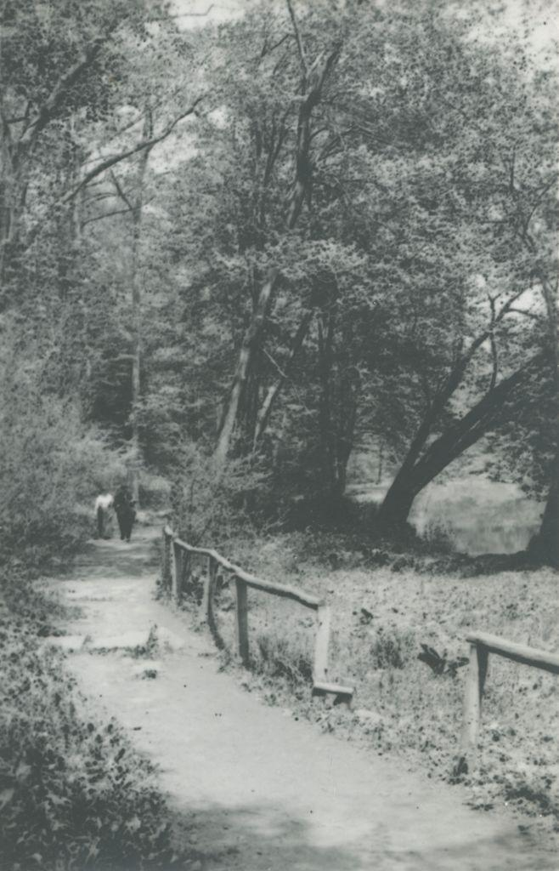

Scene 3
Rogers, James Gamble, 1867-1947 (architect), and Weston, Alice, 1926. Laurel Court. granite (rock), created 1902-1906. JSTOR, https://jstor.org/stable/community.35168802. Accessed 20 Oct. 2025.
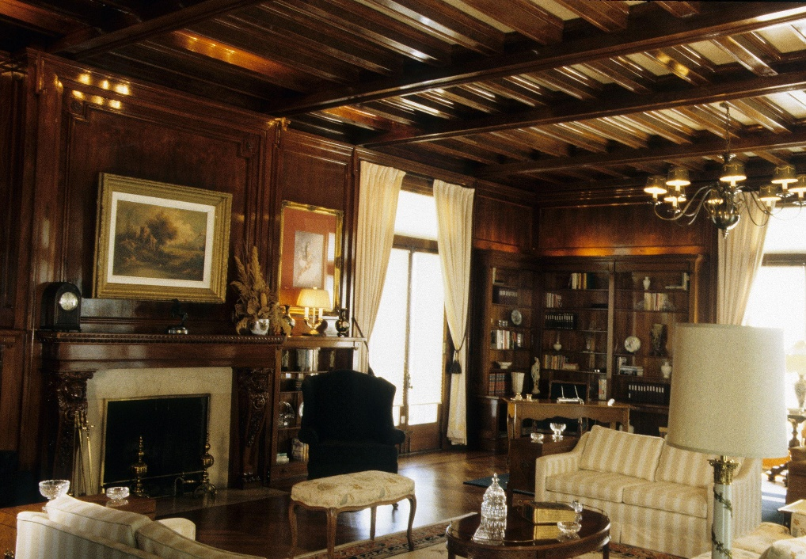
Scene 4 (Night time, twin beds replaces with one queen)
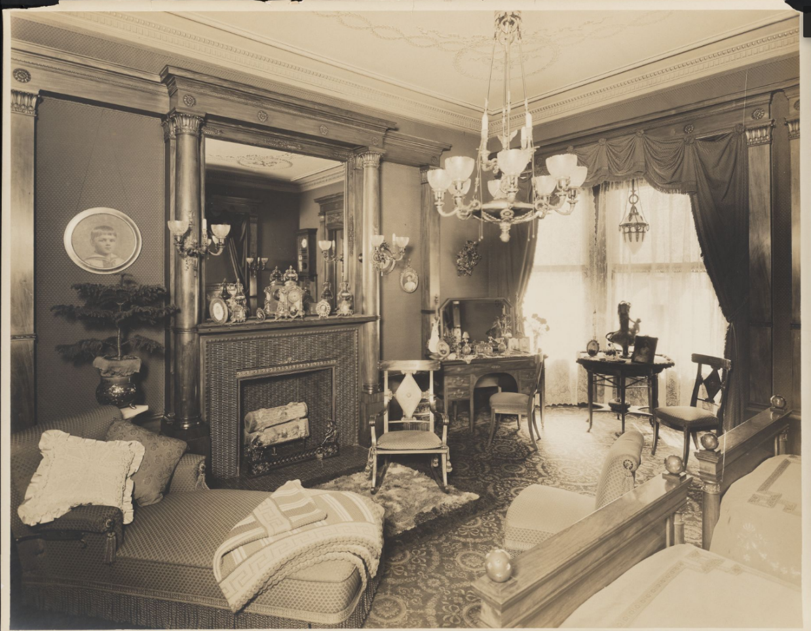
Photographer: Wurts Bros. (New York, N.Y.). Bedroom. gelatin silver print. Museum of the City of New York (MCNY), JSTOR, https://jstor.org/stable/community.16504464. Accessed 20 Oct. 2025.

Scene 5
Byron Company (New York, N.Y.). Interiors, Bedroom. 1905. Museum of the City of New York, JSTOR, https://jstor.org/stable/community.12122614. Accessed 20 Oct. 2025.
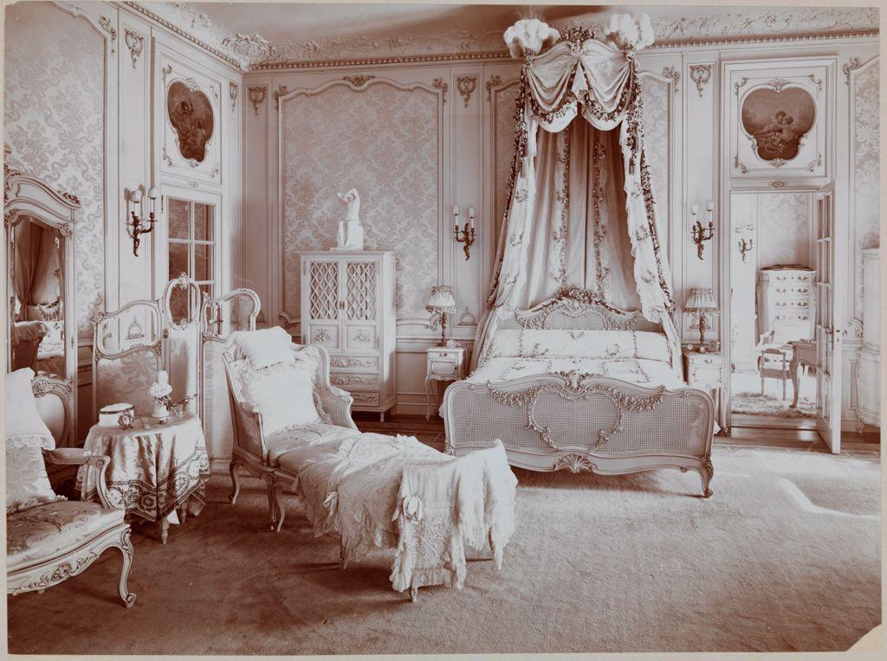
Scene 6 (I like this design but on a slightly smaller scale)
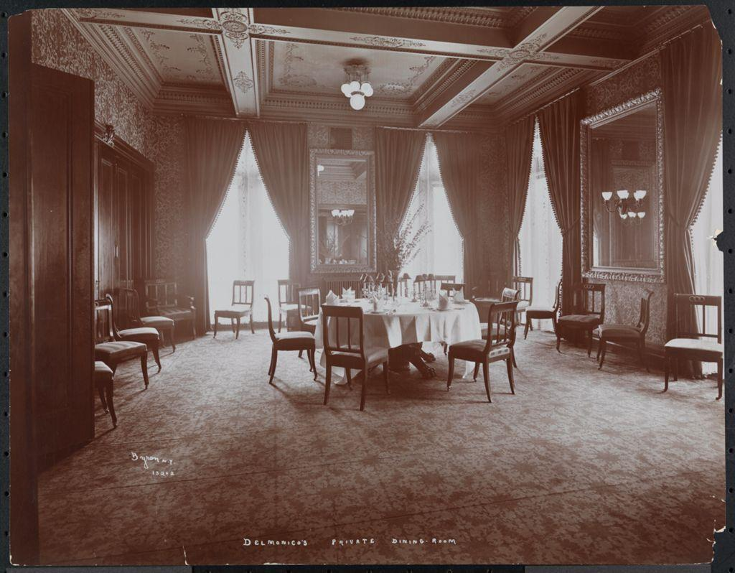
Byron Company (New York, N.Y.). Delmonico’s, Private Dining-Room. 1902. Museum of the City of New York, JSTOR, https://jstor.org/stable/community.12166831. Accessed 20 Oct. 2025.

Scene 7 (Replace couch with writing desk like the script mentions)
Byron Company (New York, N.Y.). Interiors, Miss Ford, Sitting Room. 1896. Museum of the City of New York, JSTOR, https://jstor.org/stable/community.12146709. Accessed 20 Oct. 2025.
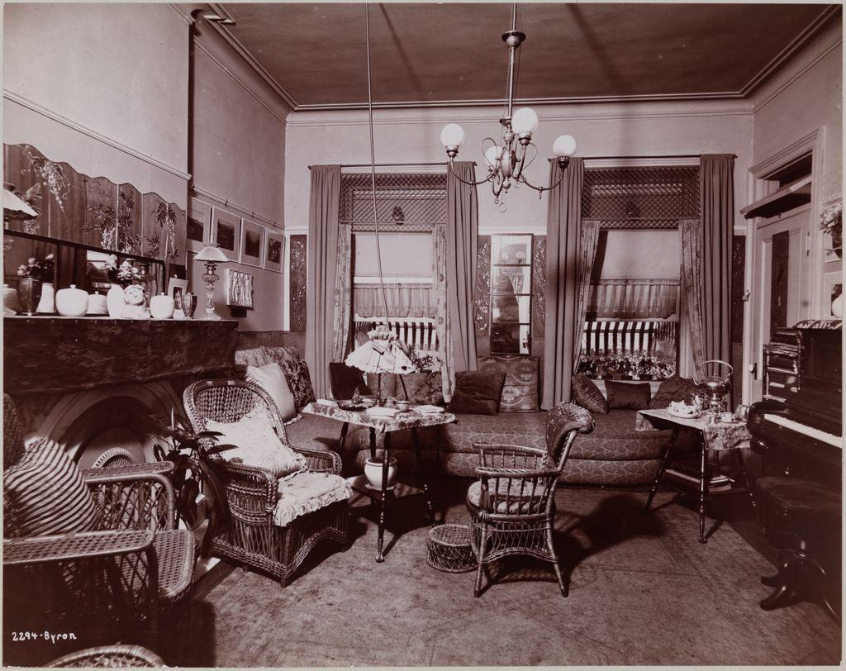
Scene 8
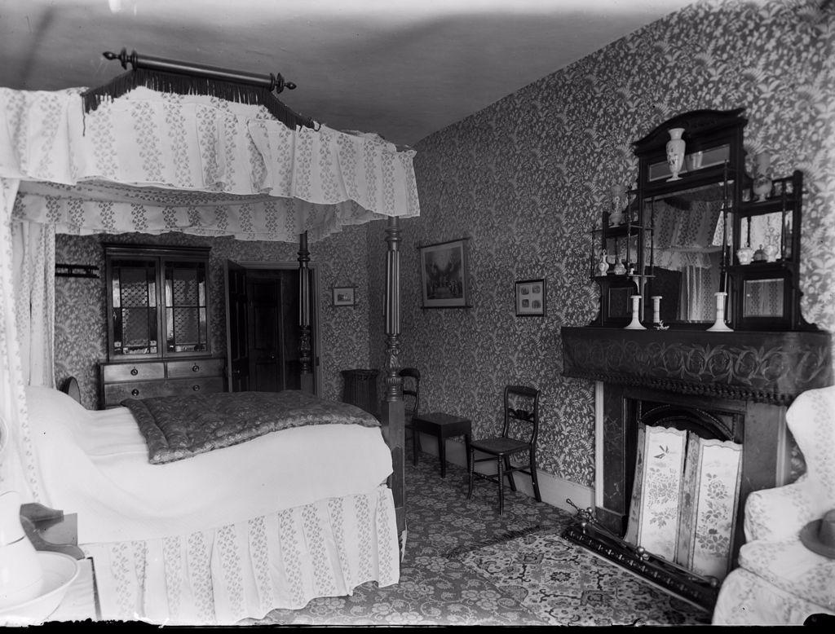
Catharine Weed Barnes Ward (American, 1851-1913). Amesbury Bedroom In George Inn. negative, gelatin on glass, ca. 1892. George Eastman Museum. George Eastman Museum. Artstor, JSTOR, https://jstor.org/stable/community.15014646. Accessed 20 Oct. 2025.

Scene 9

Scene 9
Byron Company (New York, N.Y.). [Bedroom.]. 1904. Museum of the City of New York, JSTOR, https://jstor.org/stable/community.12131522. Accessed 20 Oct. 2025.
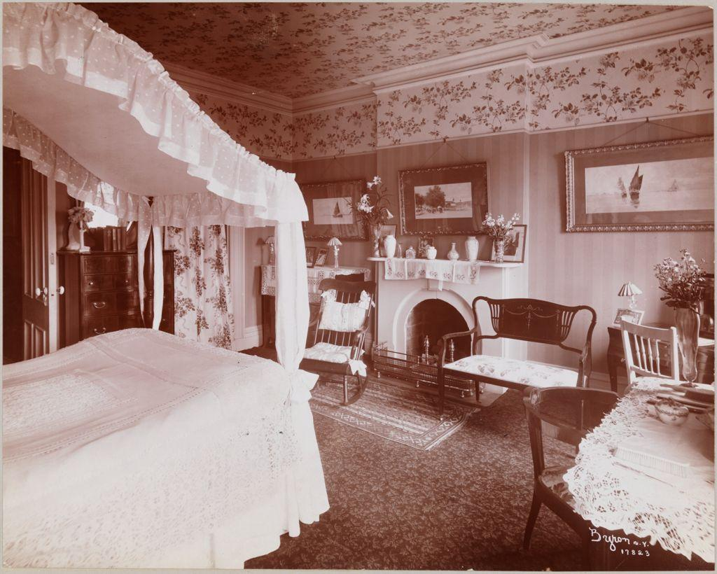
Scene 10
Byron Company (New York, N.Y.). Slums, Characters. ca. 1897. Museum of the City of New York, JSTOR, https://jstor.org/stable/community.12145820. Accessed 20 Oct. 2025.
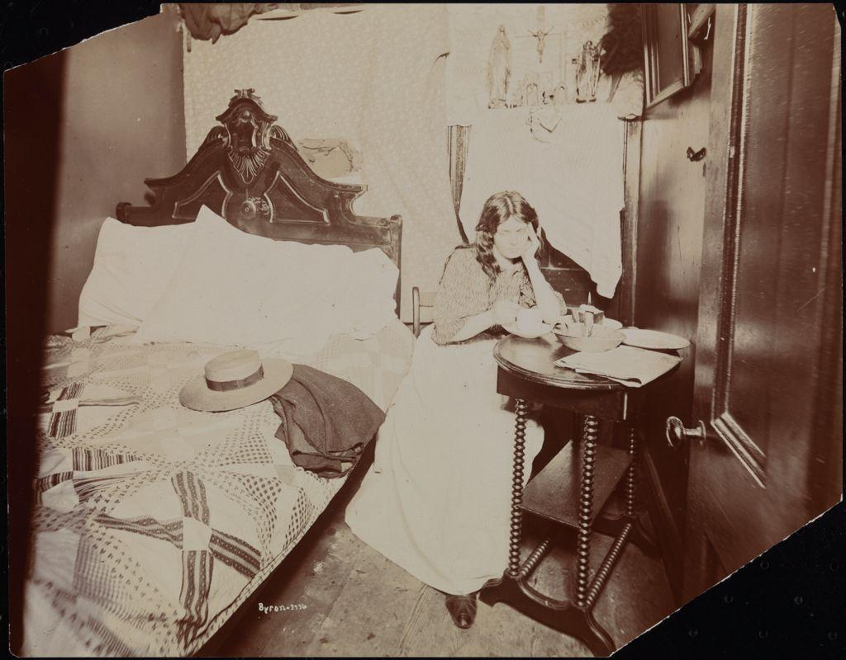

The Whore
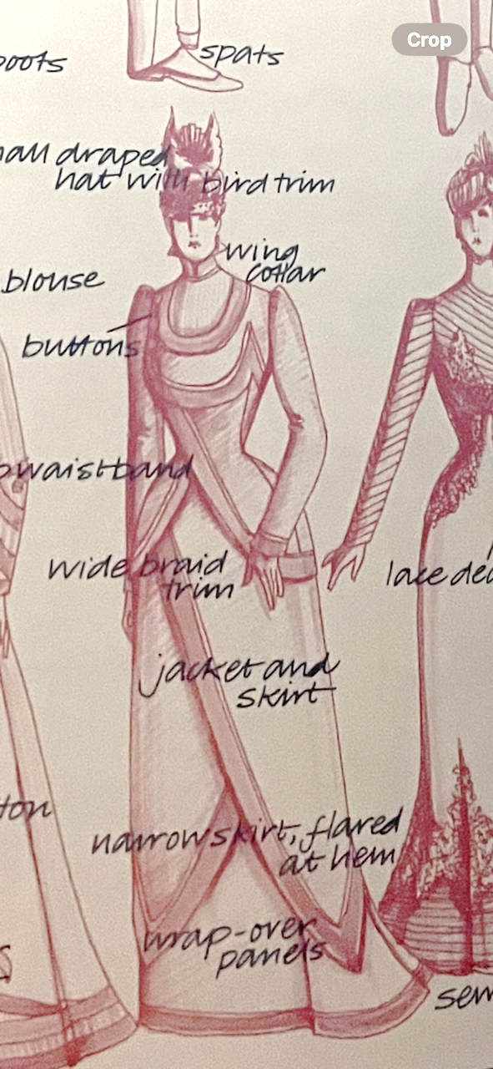
The Whore
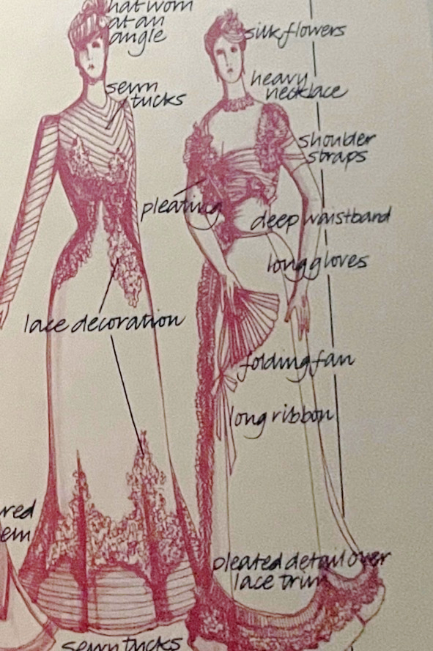

Peacock, John. Costume: 1066 to the Present. Thames & Hudson, 2006.
The Soldier
Steiner, Jörg C. “Hungarian Army - the Landforces on Crete 1897/98.” Austro, www.austro-hungarian-army.co.uk/troopscreta.htm. Accessed 19 Oct. 2025. 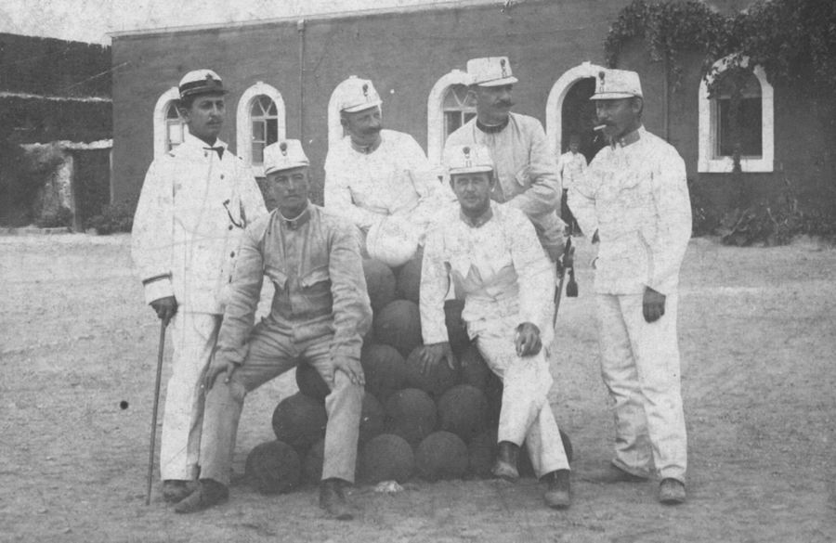
GmbH, Typoheads. “Museum of Military History.” Museum of Military History, www.hgm.at/en/. Accessed 19 Oct. 2025.
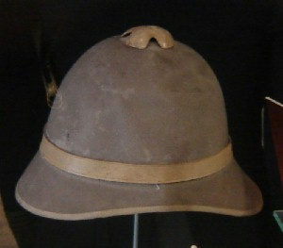
The Parlor Maid
Thomas Francis Beard (American illustrator, 1842-1905). A Substitute Bill [Illustration for Puck]. ink on illustration board, ca. 1890 (creation). Adjunct Module C: World Art, JSTOR, https://jstor.org/stable/community.31587024. Accessed 19 Oct. 2025.
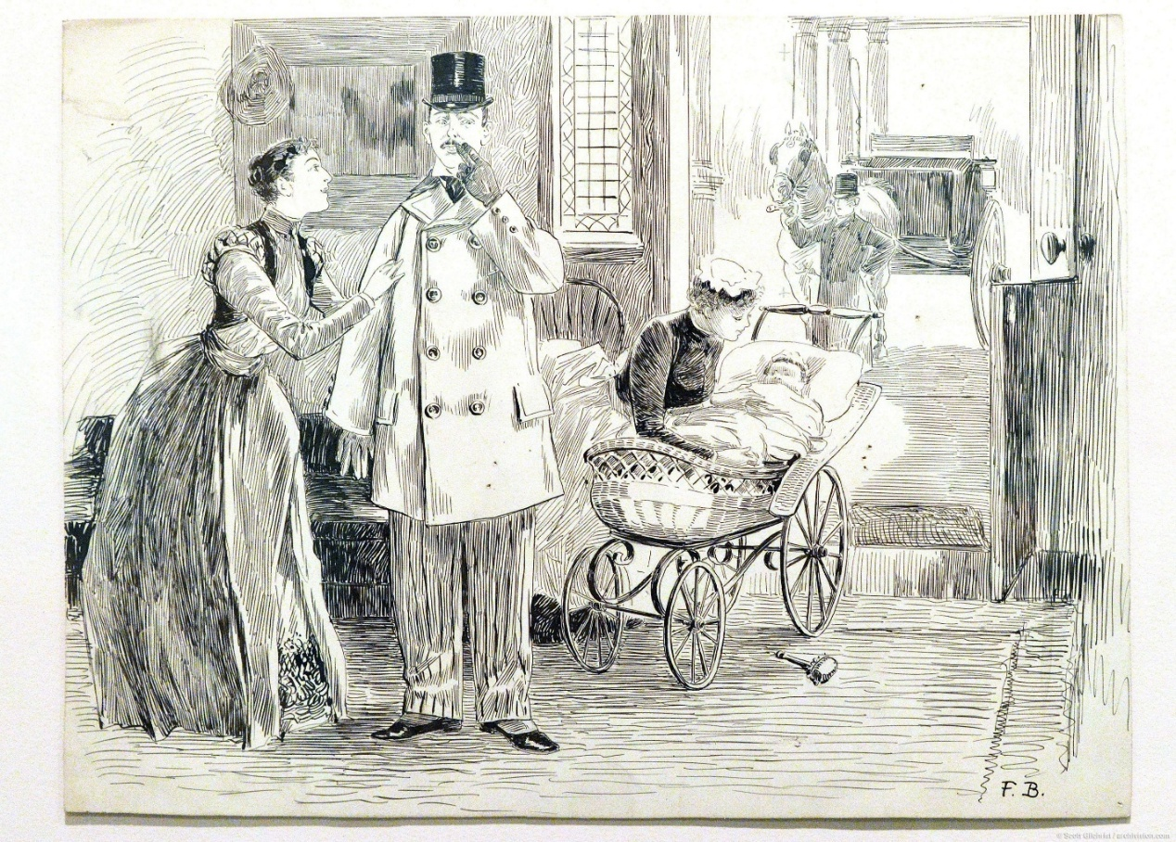
Pissarro, Camille, 1830-1903. Young Maid. oil on canvas, 1896. Art Institute of Chicago, JSTOR, https://jstor.org/stable/community.13602667. Accessed 19 Oct. 2025.

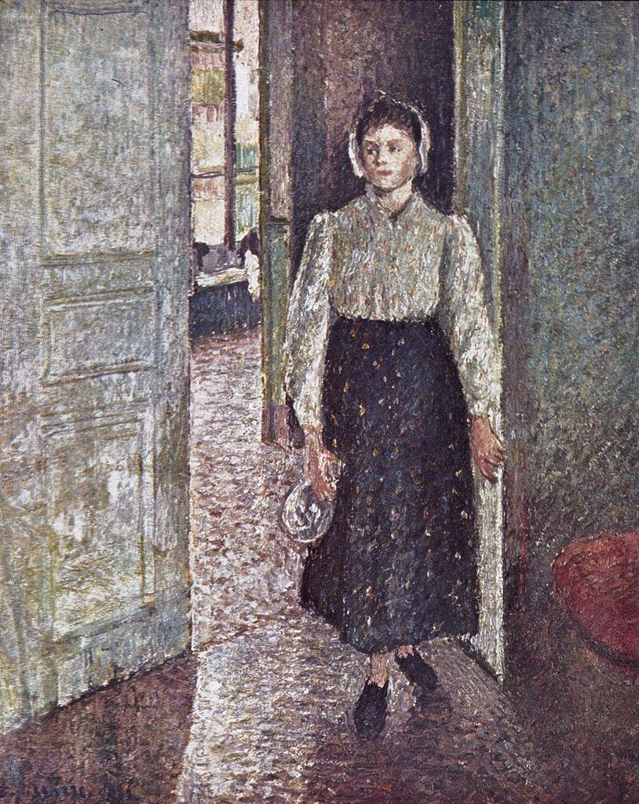
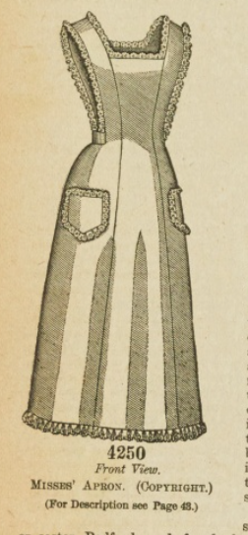
Pissarro, Camille, 1830-1903. Young Maid. oil on canvas, 1896. Art Institute of Chicago, JSTOR, https://jstor.org/stable/community.13602667. Accessed 19 Oct. 2025.

The Young Gentleman
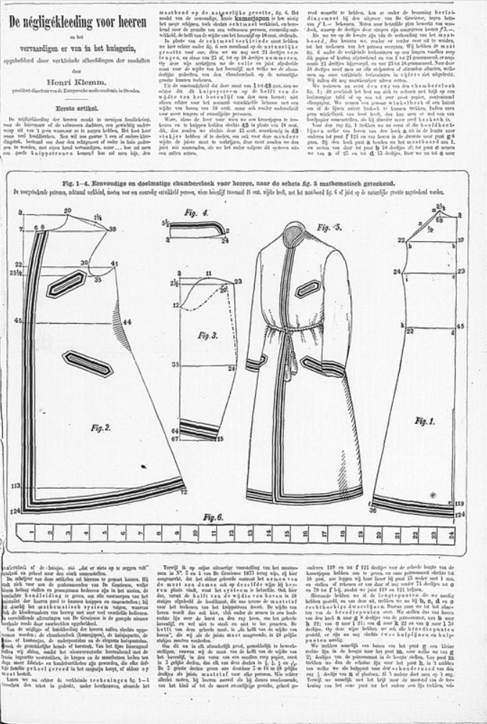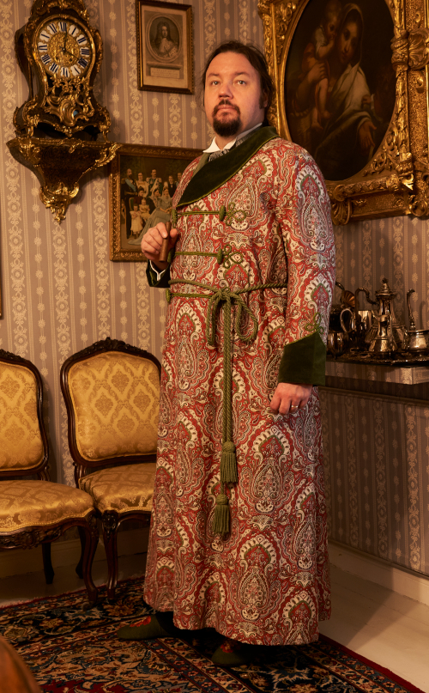
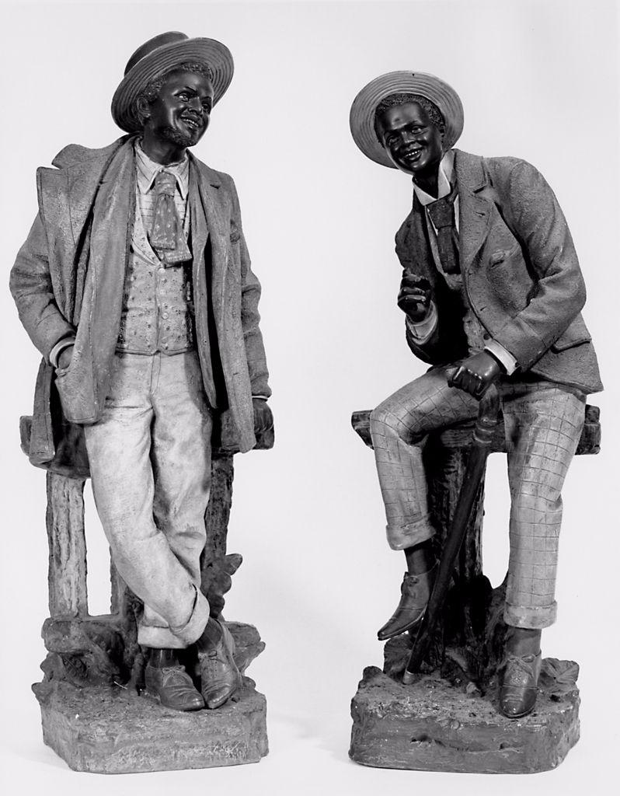
GmbH, Typoheads. “Museum of Military History.” Museum of Military History, www.hgm.at/en/. Accessed 19 Oct. 2025.
ANONYMOUS / AUSTRIA (early XX century), artist. Statue. Two Figures of Black Men. Earthenware., Ca. 1900. JSTOR, https://jstor.org/stable/community.14792853. Accessed 19 Oct. 2025.

The Young Wife
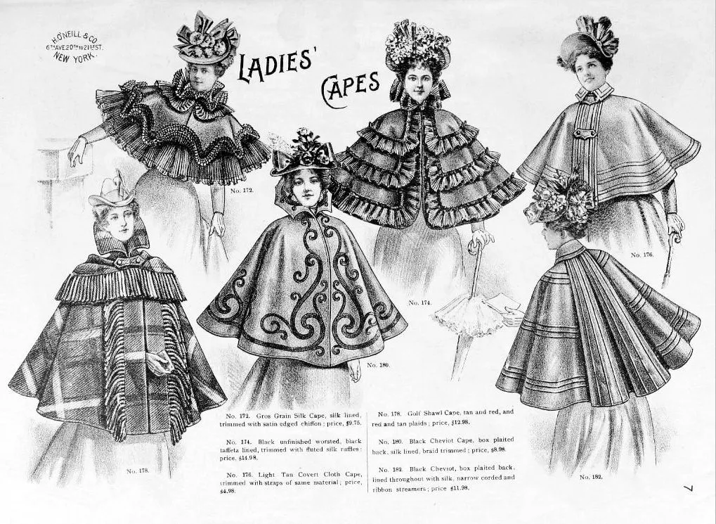
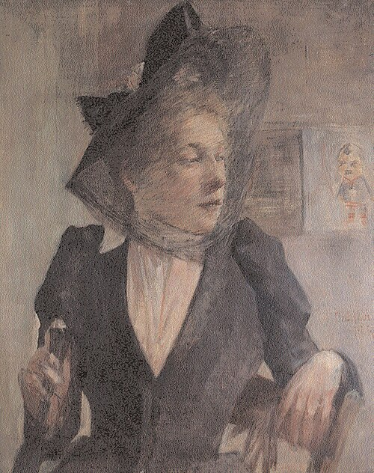
GmbH, Typoheads. “Museum of Military History.” Museum of Military History, www.hgm.at/en/. Accessed 19 Oct. 2025.

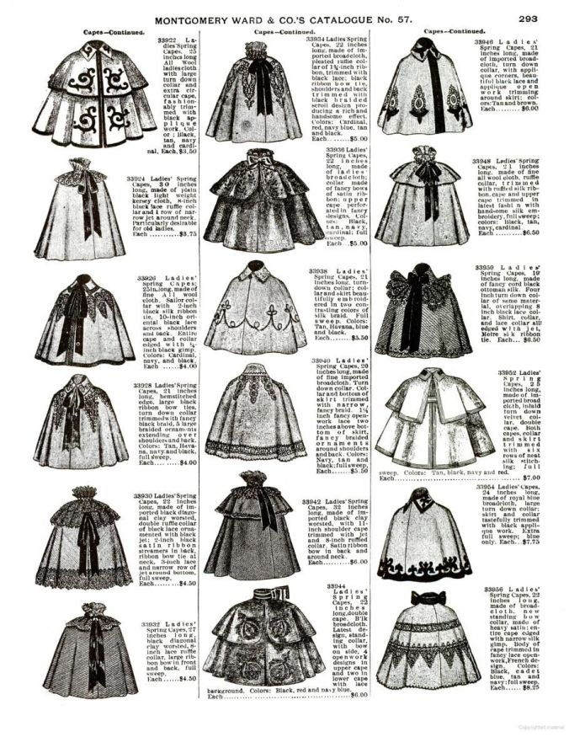
Or this 1895 Montgomery Ward catalog: https://lilyabsinthe.com/capes-capelets-in-the-1890s/
Emmet, Boris. Montgomery Ward and Co: Catalogue and Buyer’s Guide No 57, Spring and Summer 1895: An Unabridged Reprint of the Original Edition. Dover, 1969.

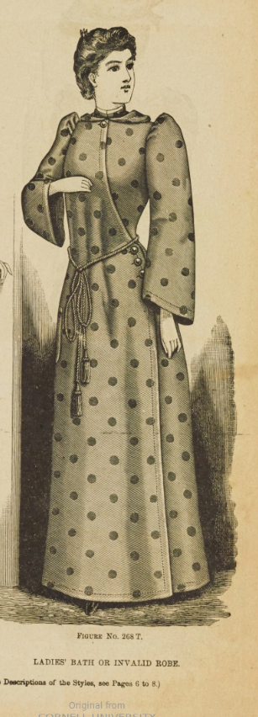
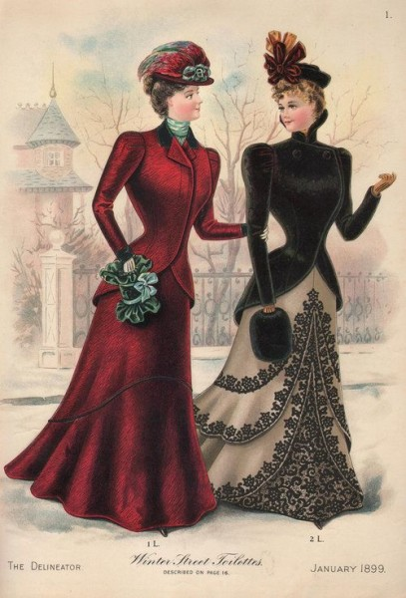
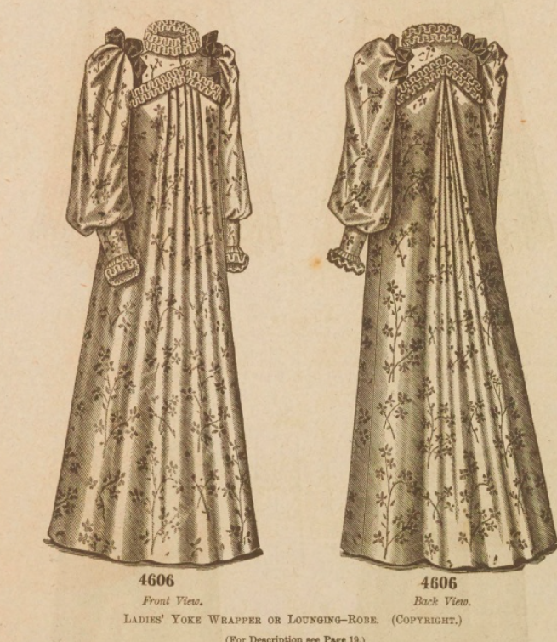
The Delineator Magazine Fragments. The Butterick Company, 1898.

The husband
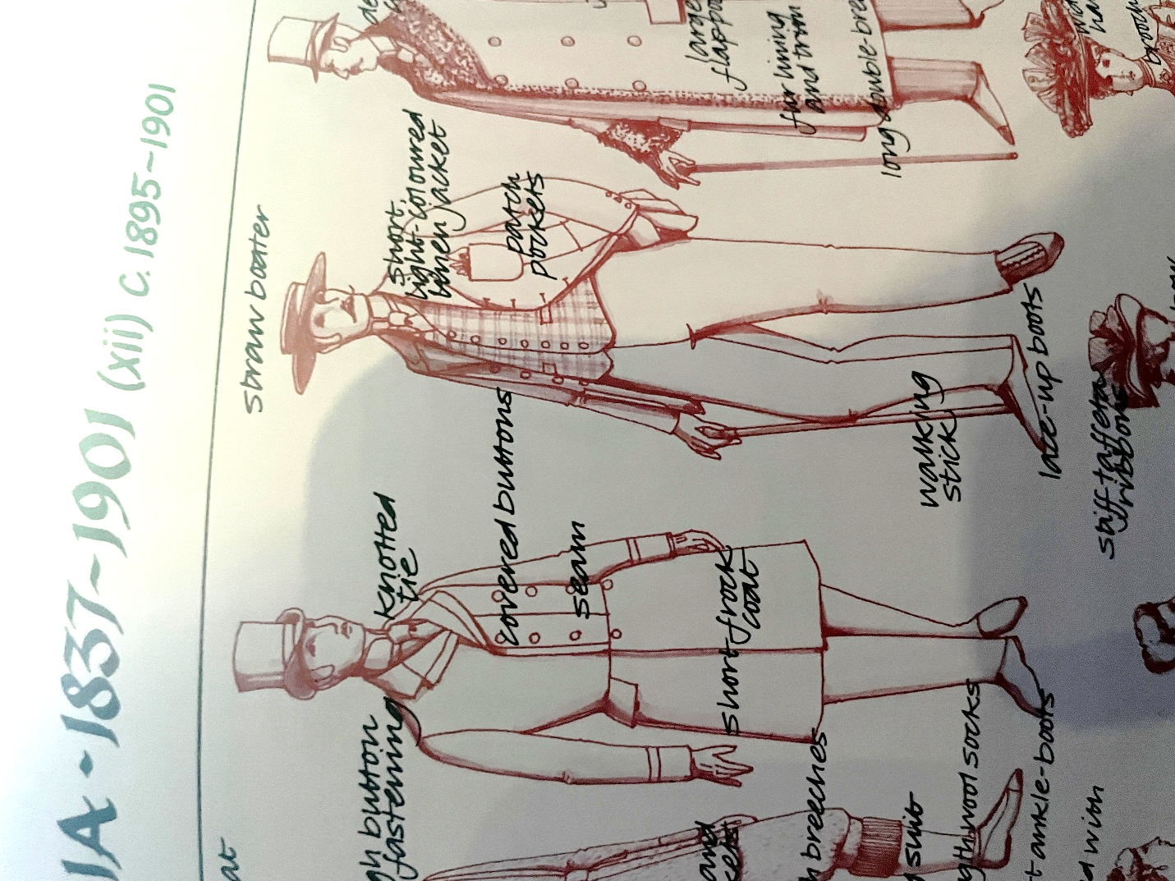
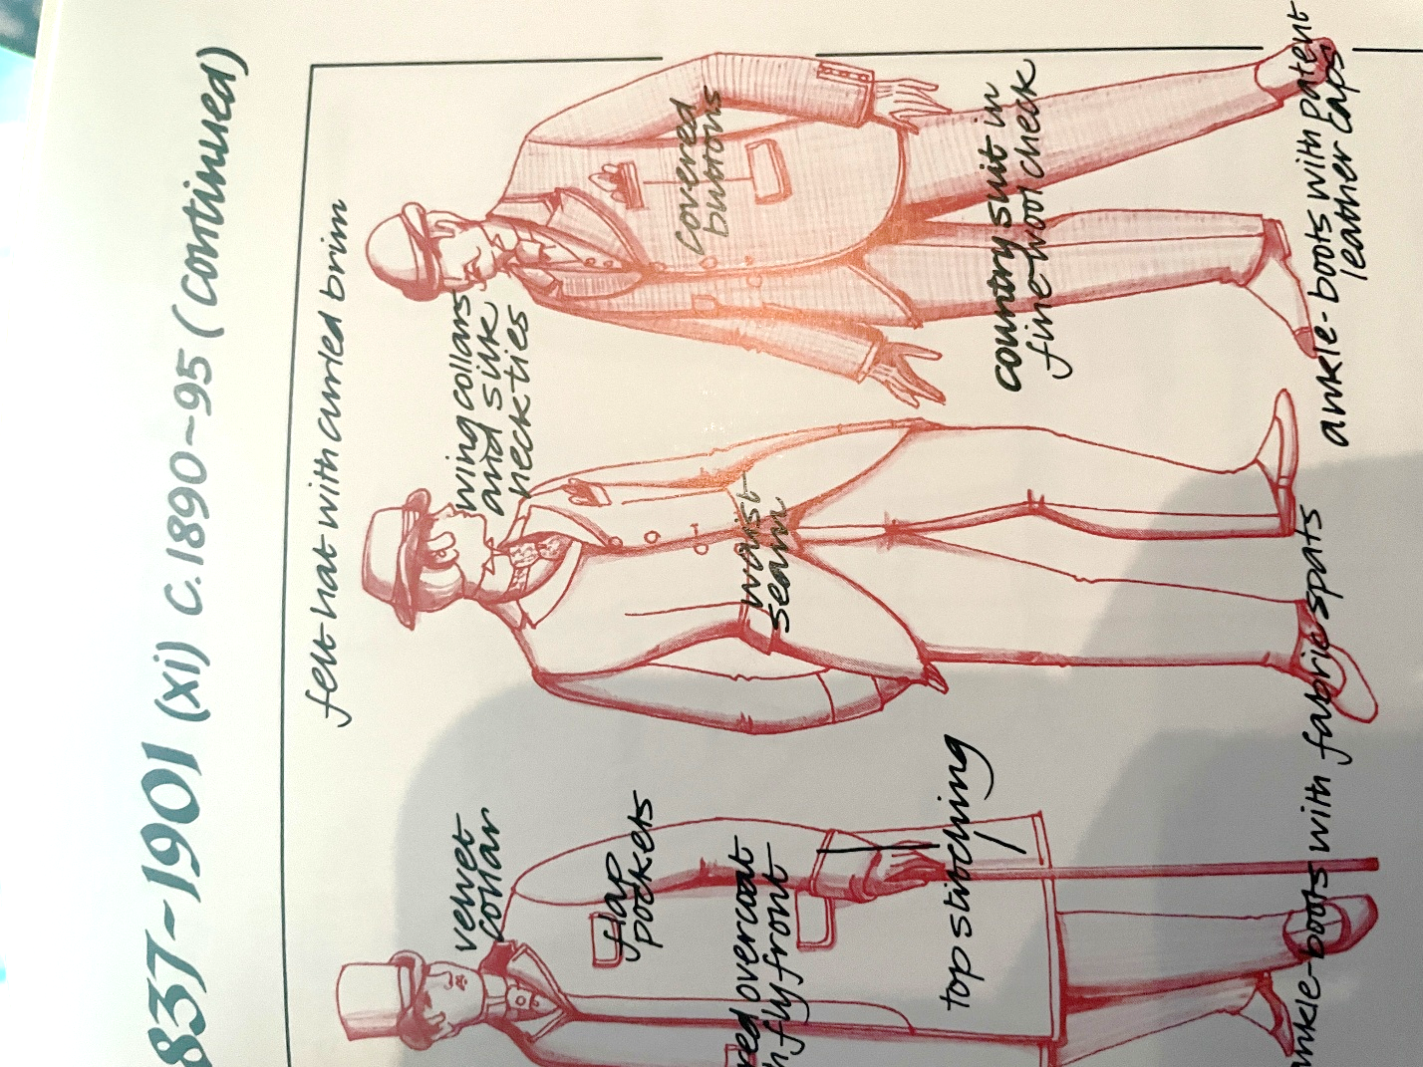

Peacock, John. Costume: 1066 to the Present. Thames & Hudson, 2006

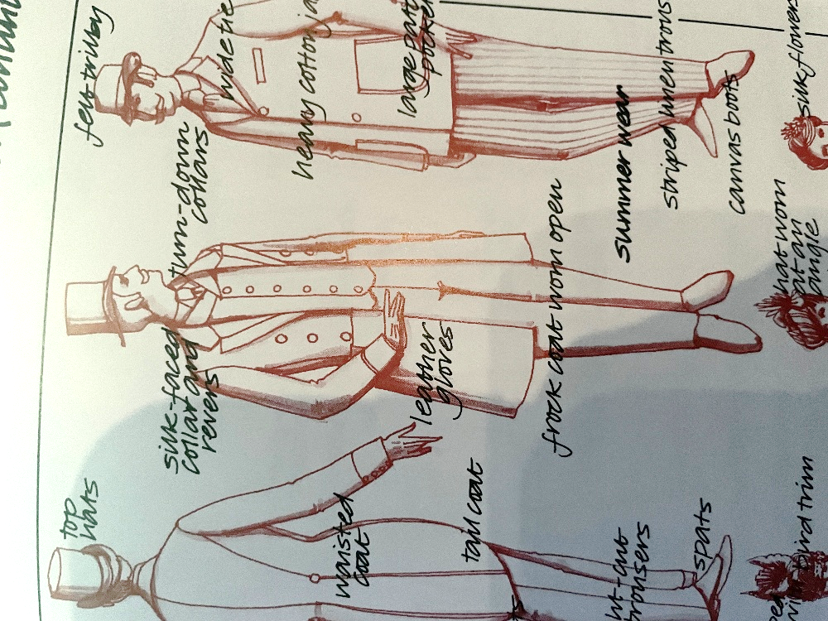
Sears: Catalogue. Vol. 112, Sears Canada, 1984.
V

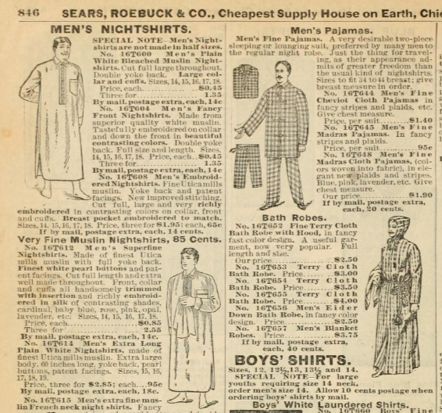

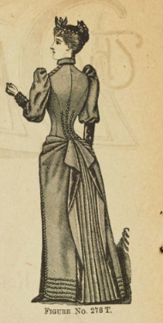
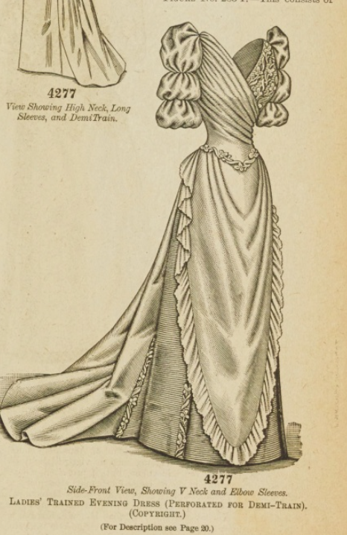
The Little Miss

DELINEATOR

The Delineator Magazine Fragments. The Butterick Company, 1898. ^
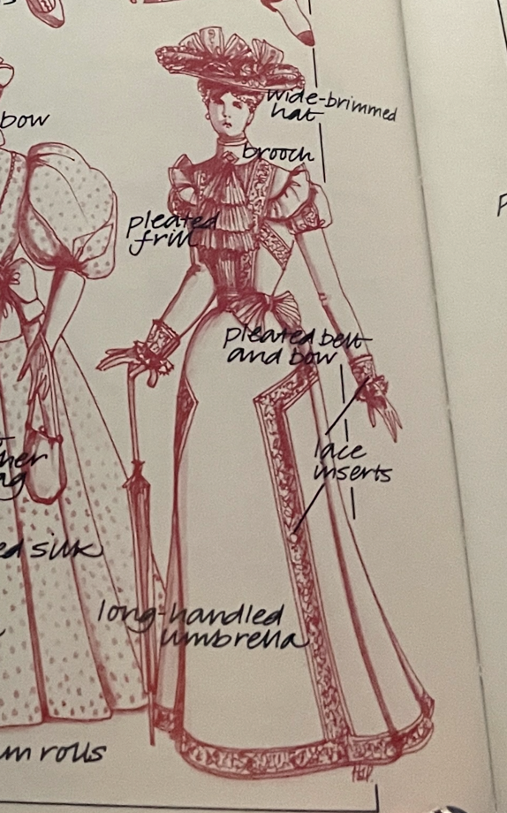
Peacock, John. Costume: 1066 to the Present. Thames & Hudson, 2006

The Poet

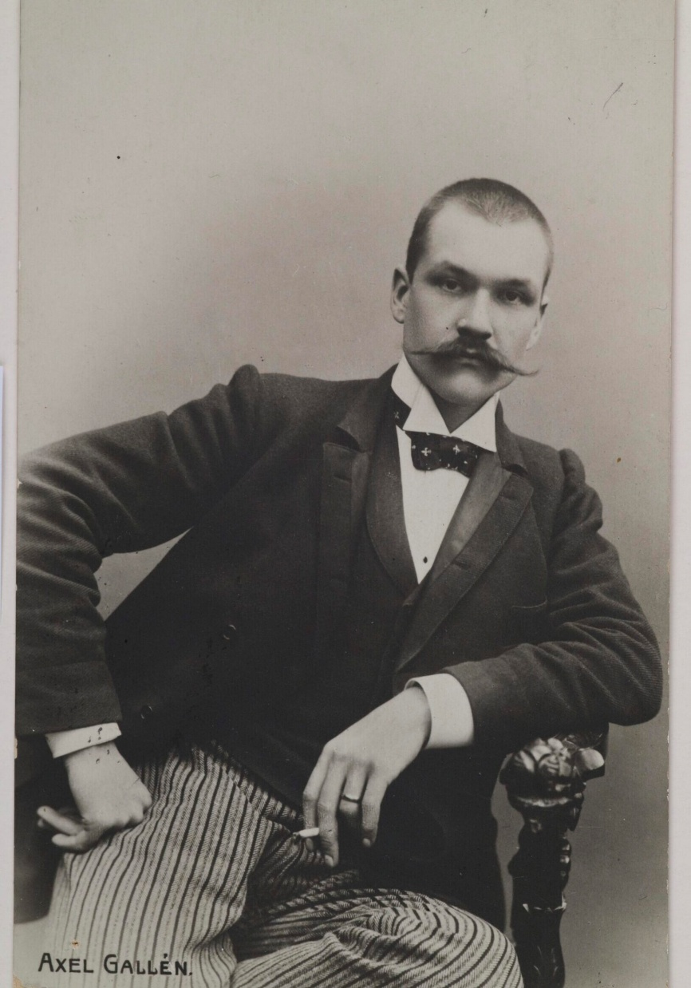
The Poet
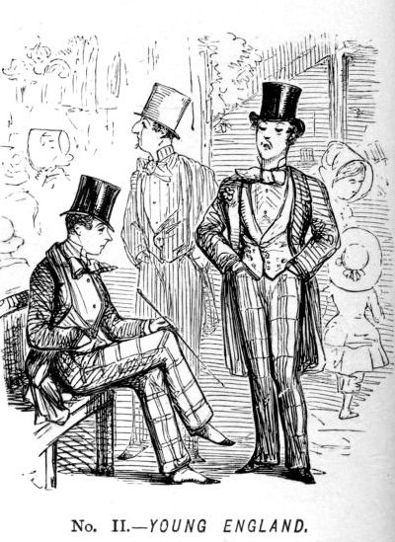

The Actress

the Delineator Magazine Fragments. The Butterick Company, 1898.

“Artist’s Studio - Gallen-Kallelan Museo.” Gallen, 24 Oct. 2024, gallen-kallela.fi/en/studio/.

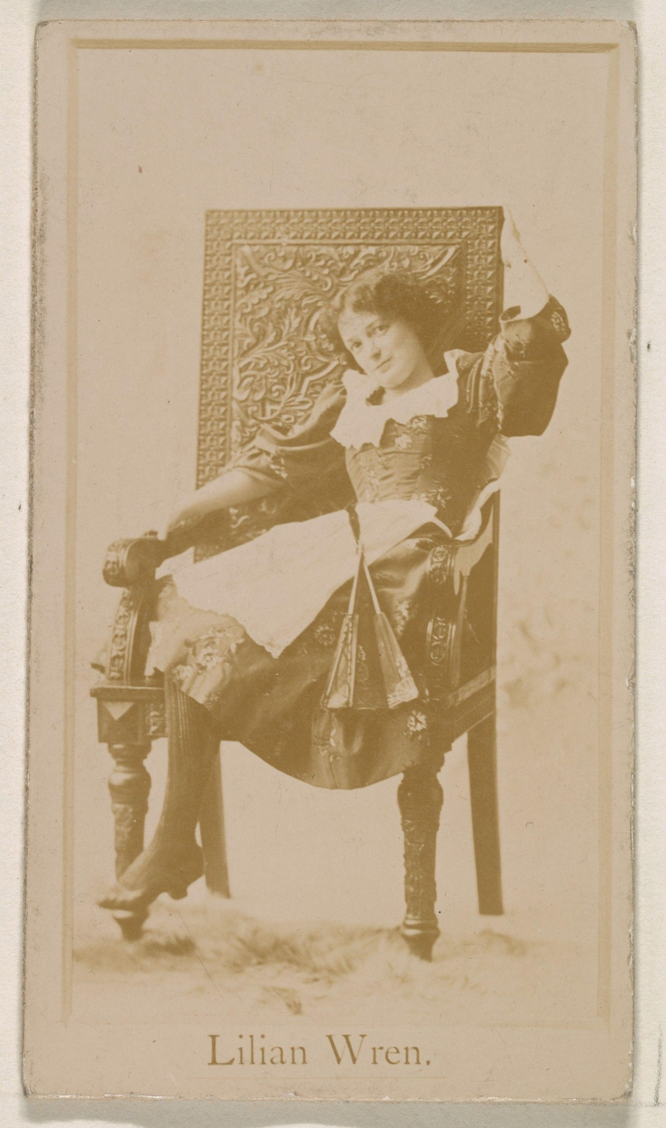
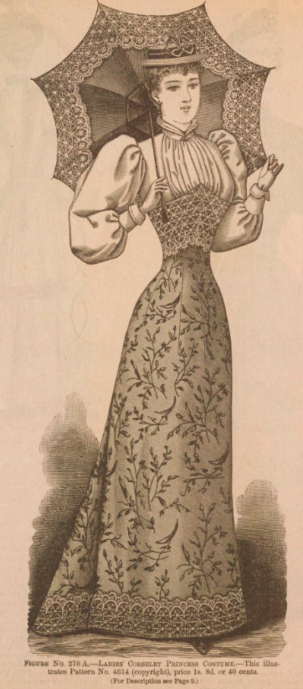
The Actress

the Delineator Magazine Fragments. The Butterick Company, 1898.

Publisher: Issued by Kinney Brothers Tobacco Company. Lilian Wren, from the Actresses Series (N245) Issued by Kinney Brothers to Promote Sweet Caporal Cigarettes. Albumen photograph, 1890. The Metropolitan Museum of Art, JSTOR, https://jstor.org/stable/community.34711425. Accessed 19 Oct. 2025.

The Count

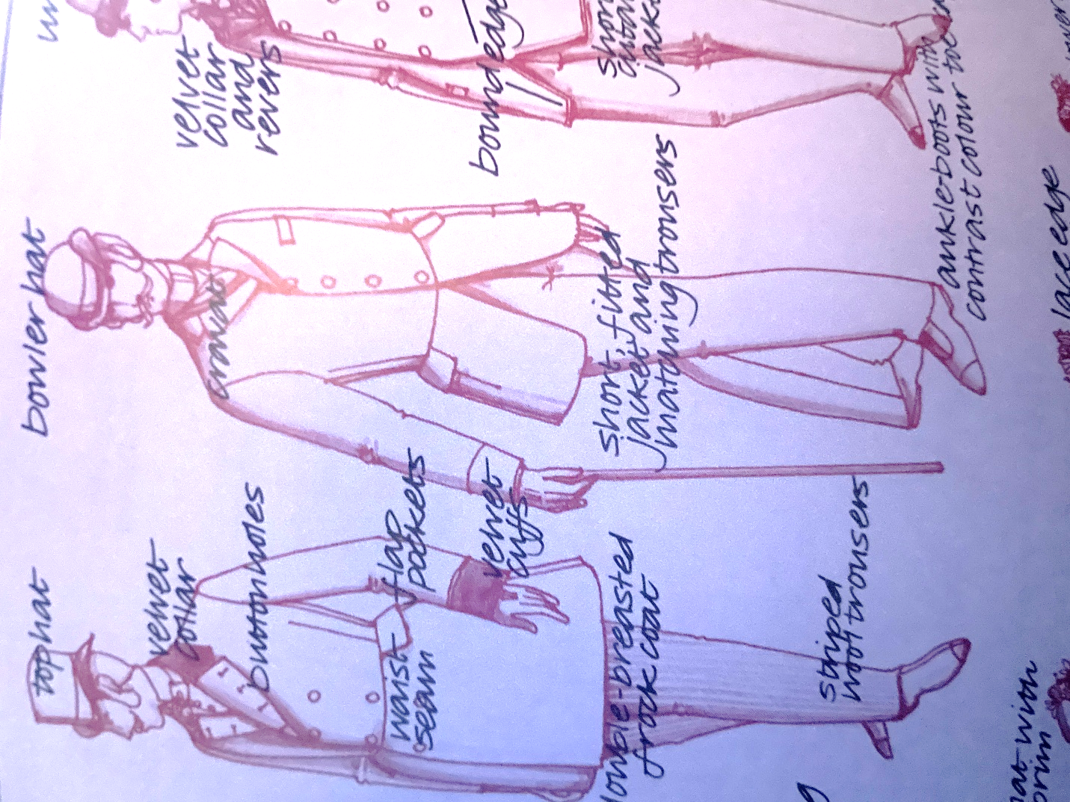
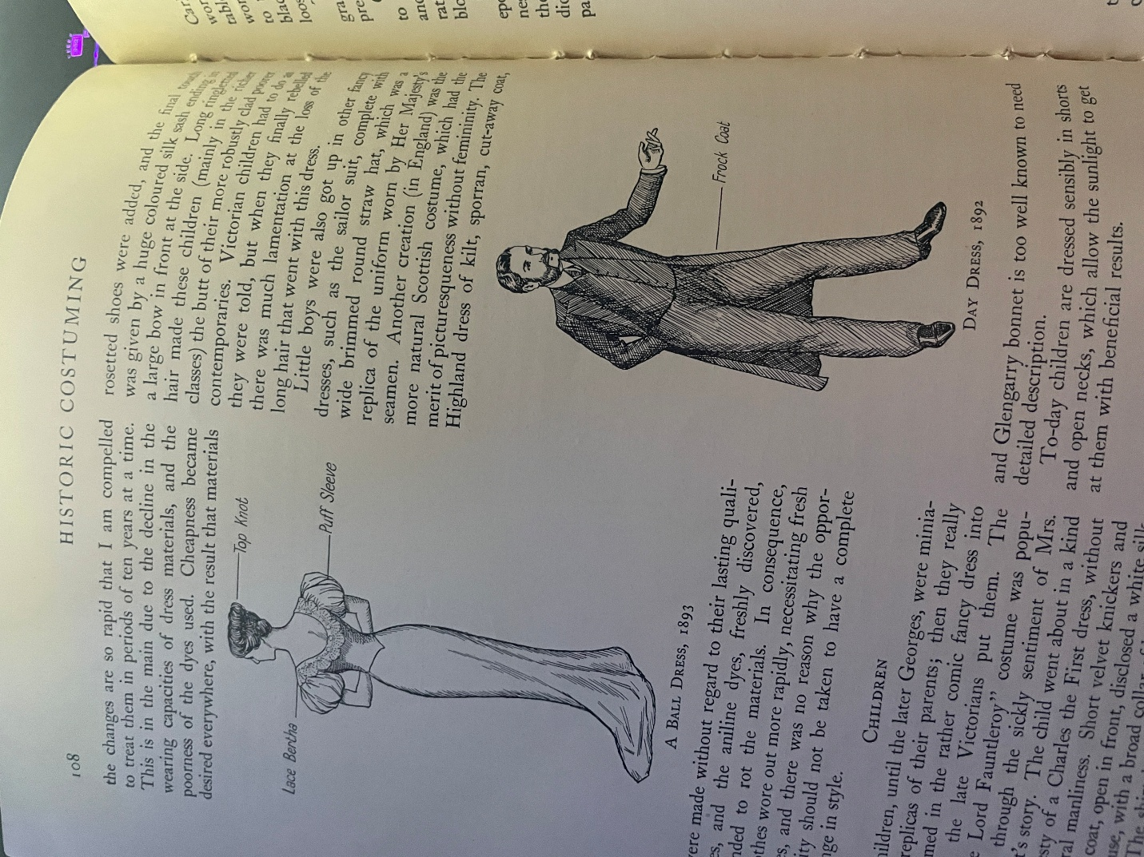
Peacock, John. Costume: 1066 to the Present. Thames & Hudson, 2006
Truman, Nevil. Historic Costuming. Domville -Fife Press, 2020.

Emotional Research
Scene 1
“Lovers by the Ha’Penny Bridge, Dublin City: The Story behind My Painting.” Vincent Keeling, www.vincentkeeling.com/blogs/news/lovers-by-the-hapenny-bridge-dublin-city-the-story-behind-my-painting. Accessed 19 Oct. 2025.
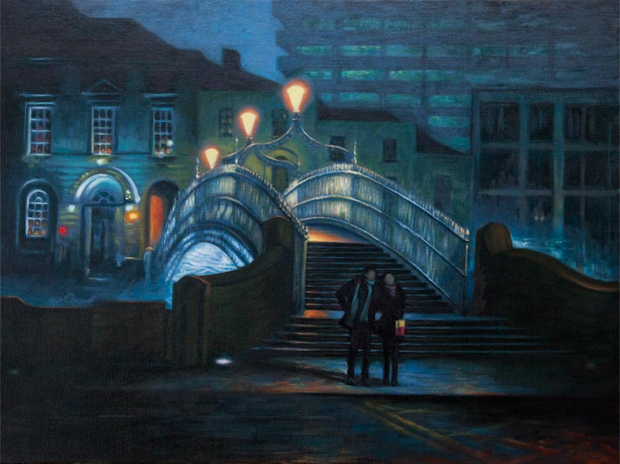
Scene 2
Kova, Julia. Sunset View from the Forest · Free Stock Photo, www.pexels.com/photo/sunset-view-from-the-forest-10433431/. Accessed 20 Oct. 2025.
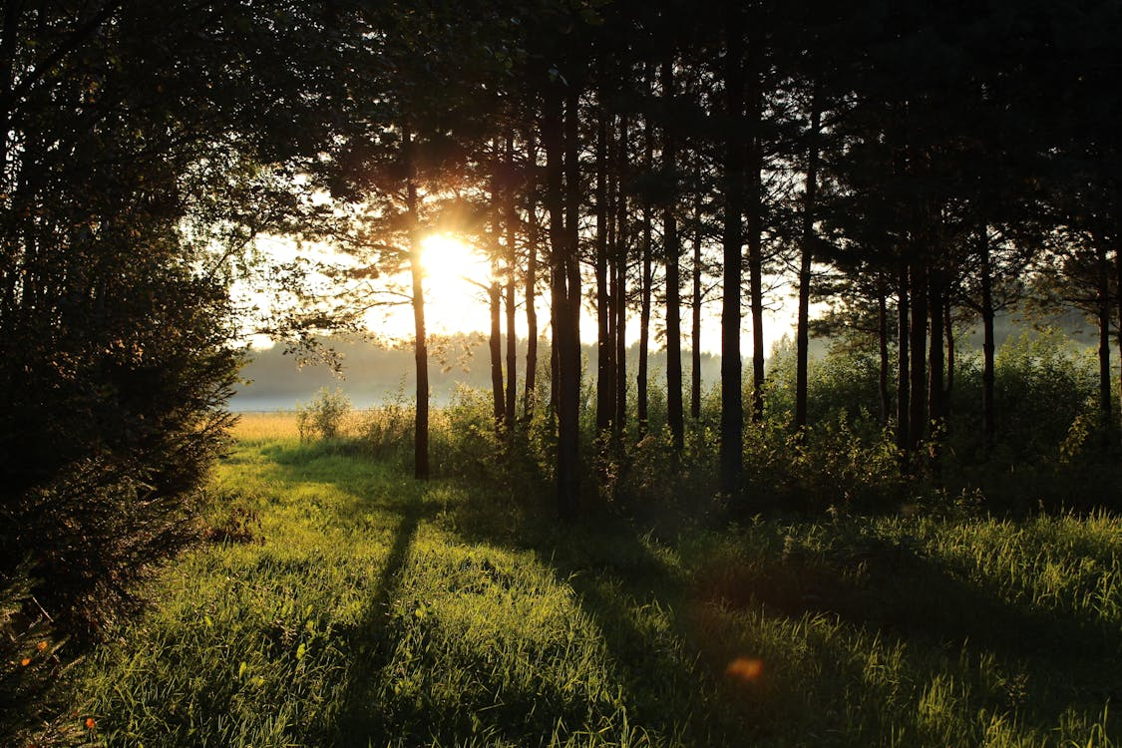

Scene 3
Cottonbro studio. Man Wearing Black Suit · Free Stock Photo, www.pexels.com/photo/man-wearing-black-suit-2955376/. Accessed 20 Oct. 2025.
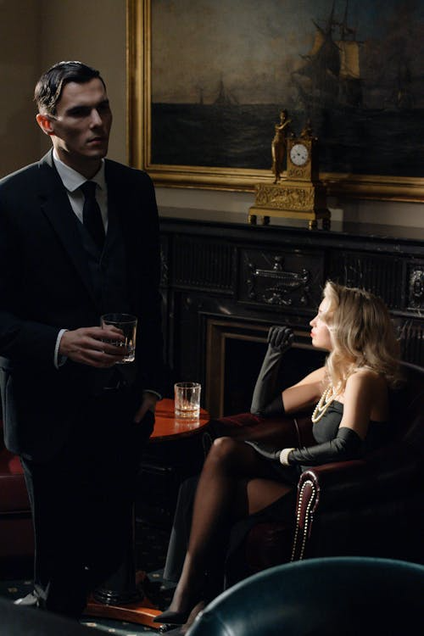
Scene 4
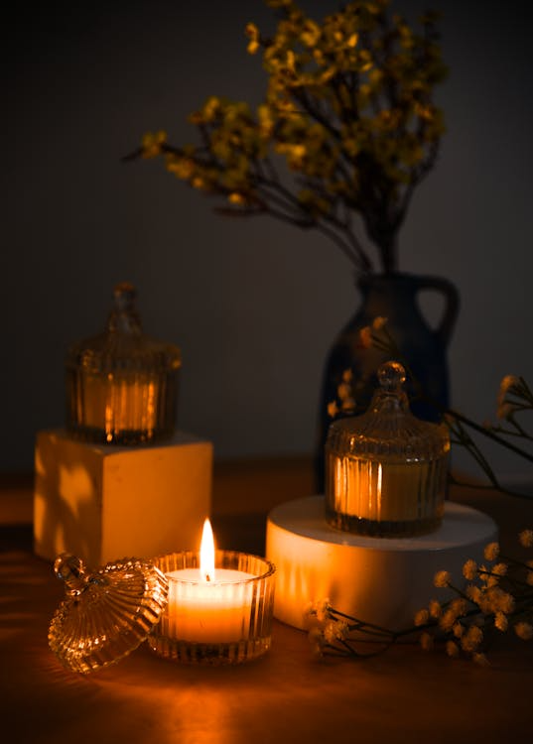
das, alok. Candles on Glass Containers · Free Stock Photo, www.pexels.com/photo/candles-on-glass-containers-3943925/. Accessed 20 Oct. 2025.

Scene 5
Massengo, Prince. Girl Studying Photos, Download The Best Free Girl Studying Stock Photos & HD Images, www.pexels.com/search/girl%20studying/. Accessed 20 Oct. 2025.
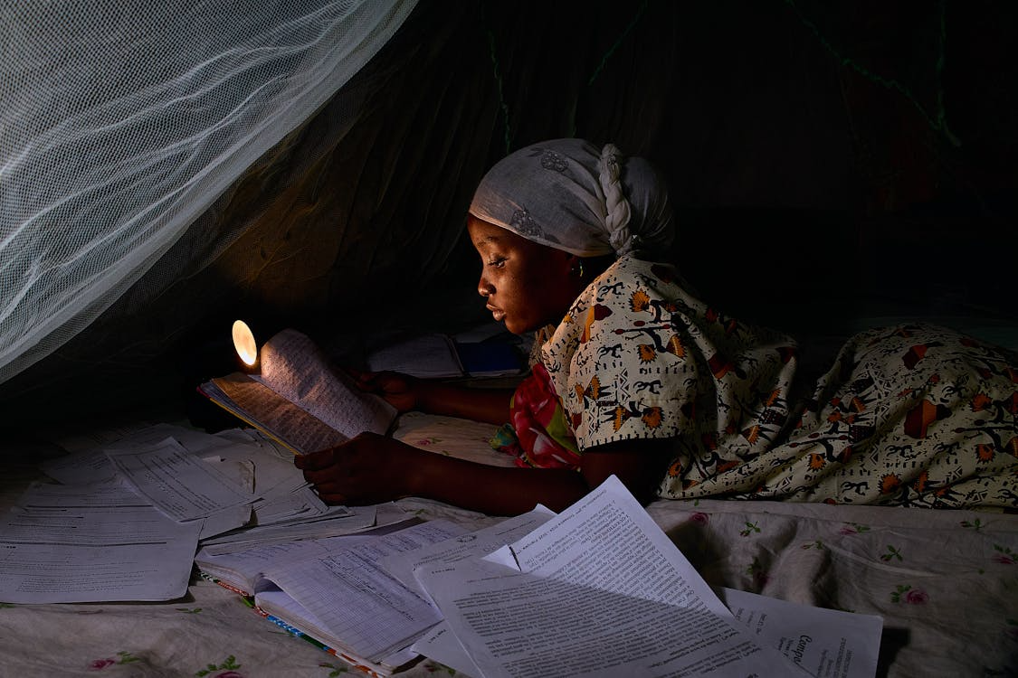

Scene 6
cottonbro studio. Woman Holding a Cake While Seriously Looking at the Camera · Free Stock Photo, www.pexels.com/photo/woman-holding-a-cake-while-seriously-looking-at-the-camera-6988683/. Accessed 20 Oct. 2025.
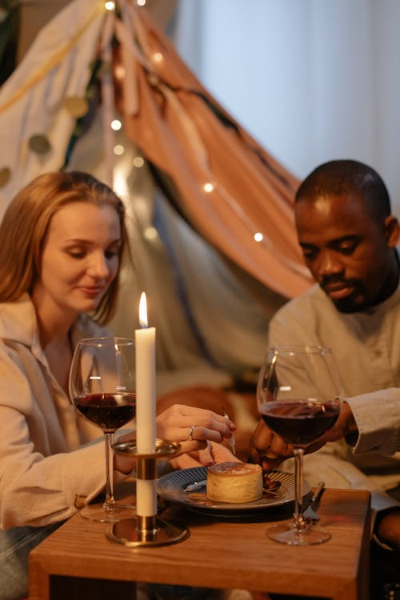

Scene 7
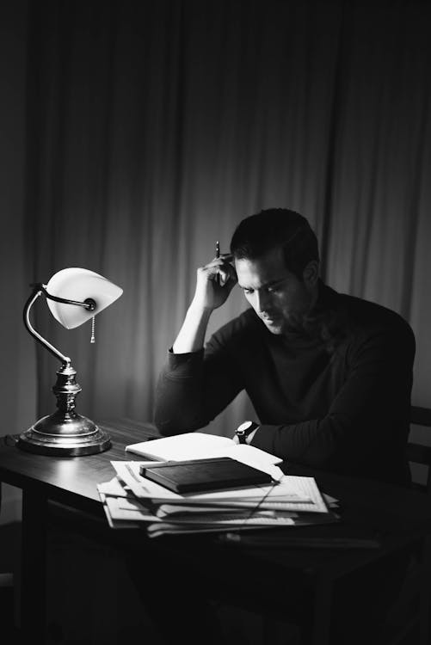
Hasanbekava, Dziana. Thoughtful Man Doing Paperwork at Table in Dark Room · Free Stock Photo, www.pexels.com/photo/thoughtful-man-doing-paperwork-at-table-in-dark-room-7063743/. Accessed 20 Oct. 2025.

Scene 8
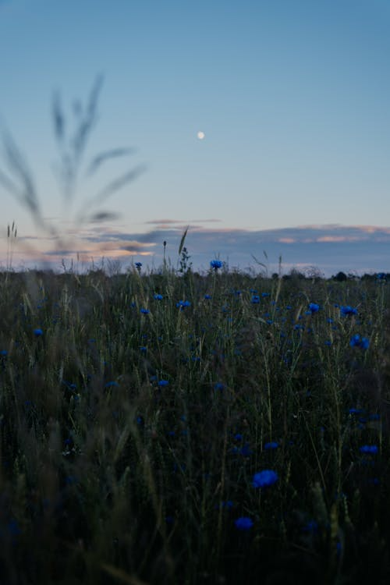
Iriser, irina. Free Selective Focus Photo of a Red Tulip Flower Stock Photo, www.pexels.com/photo/selective-focus-photo-of-a-red-tulip-flower-2480072/. Accessed 20 Oct. 2025.

Scene 9Scene 10
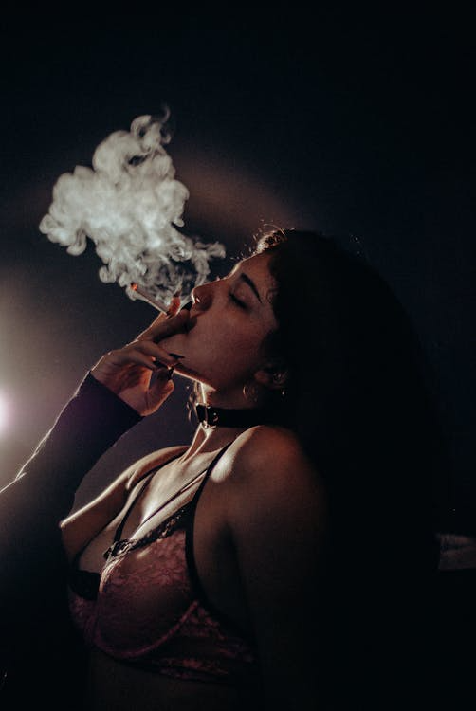
Ruiz, Hugo. A Woman Wearing a Brassiere Smoking a Cigarette · Free Stock Photo, www.pexels.com/photo/a-woman-wearing-a-brassiere-smoking-a-cigarette-9204928/. Accessed 20 Oct. 2025.

